How to Make Literacy Fun at Home for Pre-K to Grade 2
Raluca Oanea, M.Sc.A., S-LP(C) & Viki Thanos, M.Sc., S-LP(C)

WEBSITES

ENGLISH

- Florida center for reading research: http://www.fcrr.org/resources/resources_sca.html
- Tumble books: http://www.tumblebooklibrary.com/Home.aspx?categoryID=13
- Abracadabra: http://abralite.concordia.ca
- Starfall: https://www.starfall.com/
- ABC ya!: http://www.abcya.com/
- Reading Rockets: http://www.readingrockets.org/
- Robert Munsch: www.robertmunsch.com: This website has a selection of books narrated by Robert Munsch. You will need the book in order to follow the audio.
- Sight words (Dolch words): http://www.mrsperkins.com/dolch.htm

Resources for Vowels :
- https://www.havefunteaching.com/resources/
- https://www.kidzone.ws/kindergarten/vowels/index-short-vowels.htm
- http://more2.starfall.com/n/skills/vowels/play.htm?f&redir=www

FRENCH Websites:

- Conscience Phonologique (Phonological Awareness): http://rseqqca.com/wp-content/uploads/2016/06/Conscience-phonologique.pdf
- http://carrefour-education.qc.ca/guides_thematiques/premiers_pas_vers_la_lecture_la_conscience_phonologique_sur_le_web A great resource for literacy in French!
- http://www.eworkshop.on.ca/edu/pdf/mod45_conscience_phono.pdf

Grades 1 and 2

- Reading : K-Gr.6: http://www.pepit.be/exercices/maternelles/francais/determinant_lelales/page.html

- Reading comprehension : http://www.duplaisiralire.com/ (click Jeux et activités)

Free literacy Apps

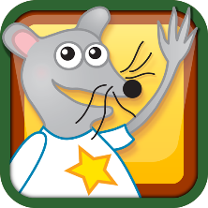
Starfall Learn to Read

The Learn to Read index content from the starfall.com website is now a FREE app!

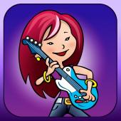
Hear Builder (Phonological Awareness)
This evidence-based, interactive program helps students improve their phonological awareness and listening skills. Students earn instruments and band members to form the rock band The Phonemix while learning to segment, blend, and manipulate sounds.
This app includes a free tour of the first level of all the activities in HearBuilder Phonological Awareness. If you have a subscription to Super Duper Learning and a student login, you can access the entire online version of the program.

Phonics 1st Grade 2 Lite
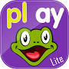
This app focuses on consonant blends with 'r' and 'l' (bl, br, cr, cl, gr, gl, pl, pr) and long vowels 'a' and 'i' with the silent e (van-vane, kit-kite). Kids will also learn the concept of long vowel digraphs (ai, ay, ee, ea) and the long vowel sounds of 'y' (windy, cry). There are 4 decodable stories to match the key lessons. The videos and games are part of our 1st grade Level 2 phonics program on http://www.kizphonics.com/phonics-program/1st-grade-level-2/ It works great with our Kiz Phonics book 5 for 1st grade Level 2. It is a great complementary product.

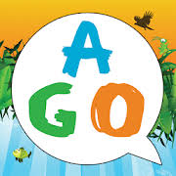
AGO Phonics Sound Pad
AGO Phonics Sound Pad is a fun tool for exploring and learning English phonic sounds and vocabulary. Touch words and images on the screen to hear clearly voiced phonic sounds with 3 high frequency words given for each phoneme.

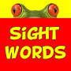
Sight Words Read and Spell app with checkmark and review - FREE – HD

Features: 300 sight words from Dolch list; presented by grade level; two modes available: read the sight word/spell the sight words!

ABC Phonics Make a Word Free - Short Vowel App for Kindergarten and First Grade kids

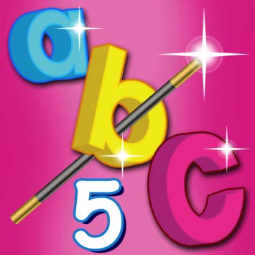
ABC MAGIC PHONICS 5-Connecting Sounds and Letters

